*Florida International University*

*School of Computing and Information Sciences*

CEN 5011- Advanced Software Engineering

Feature Document

User Story #1175

# **Modify mandatory fields to all 3 forms to the users & add honors college**

**Team Member:**

Shefali Nakum

**Product Owner(s)**:

Masoud Sadjadi

**Mentor(s)**:

Mohsen Taheri

**Instructor**: Masoud Sadjadi

# 

# **User Story – Modify mandatory fields to all 3 forms to the users & add honors college**

As a user, I would like to see the required fields before filling the forms and also see the “Honors College” in the list of colleges in the form so that I would not forget to give the required information and select the correct college respectively.

.

## **Use Case**

**Use Case ID:** (VIP-1175)

**Actor:** Student, Staff/Faculty

**Pre-conditions:**

1. “Apply for a Project” Form should open without any errors.
2. “Propose a Project” Form should open without any errors.
3. “Faculty Registration” Form should open without any errors.

**Description:**

1. User should find “Honor College” in the drop down menu of college in all the three forms.
2. User should fill all the required fields that are marked with Star * before submitting either of the three forms.

**Post-conditions:**

1. User should be able to submit the forms once the required field has been filled properly.

**Alternative Courses of Action:**

N/A

**Exceptions:**

N/A

**Related Uses Case:**

N/A

**Use Case Diagram**

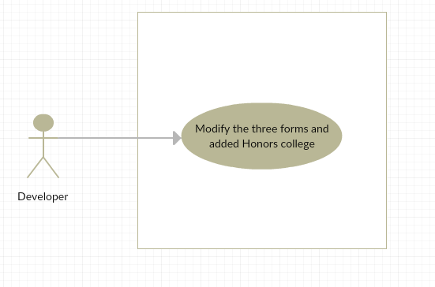

**Sequence Diagram**

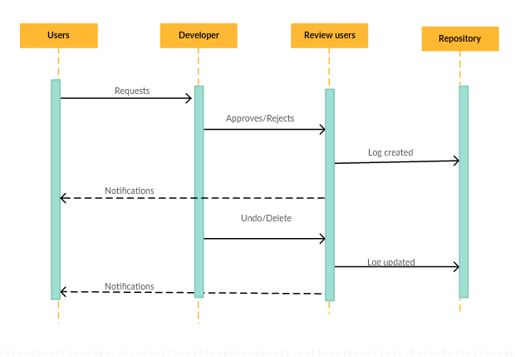

**Class Diagram**

N/A

**Unit & Integration Tests:**

**● Test Case 1(Sunny Day)**

## ○ Purpose: Test that the three form “Faculty registration form”, “Apply for a project” and “Proposing a project” is showing the required fields with a star mark.

## ○ Precondition: User has reached the VIP site and reached the respective form.

## ○ Input: Details are filled by the users.

## ○ Expected Result: User can be able to submit the forms without errors.

○ Actual Result: User is submitting the forms without errors  
○ Status: SUCCESS

**● Test Case 2(Sunny Day)**

## ○ Purpose: Test whether user is able to submit the form by selecting Honors college without selecting any school.

## ○ Precondition: User has reached the respective form.

## ○ Input: User is selecting college as “Honor College” without any school

## ○ Expected Result: User can be able to submit the forms without errors.

○ Actual Result: User is submitting the forms without errors  
○ Status: SUCCESS

**Visual User Guide**

1. **Registration form with “Honor college” and all required fields, marked with a star\***

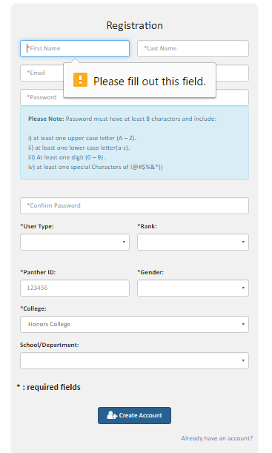

1. **Apply for a project form with “Honor college” and all required fields, marked with a star\***

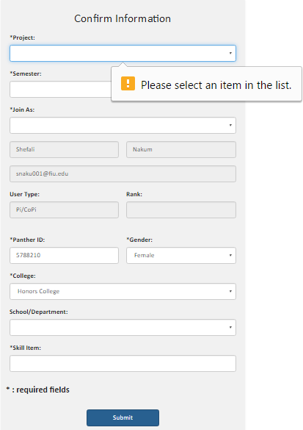

1. **Proposal for a project form with “Honor college” and all required fields, marked with a star\***

